**Steps for accepting a pull request:**

Step1: A pull request has been generated by a user

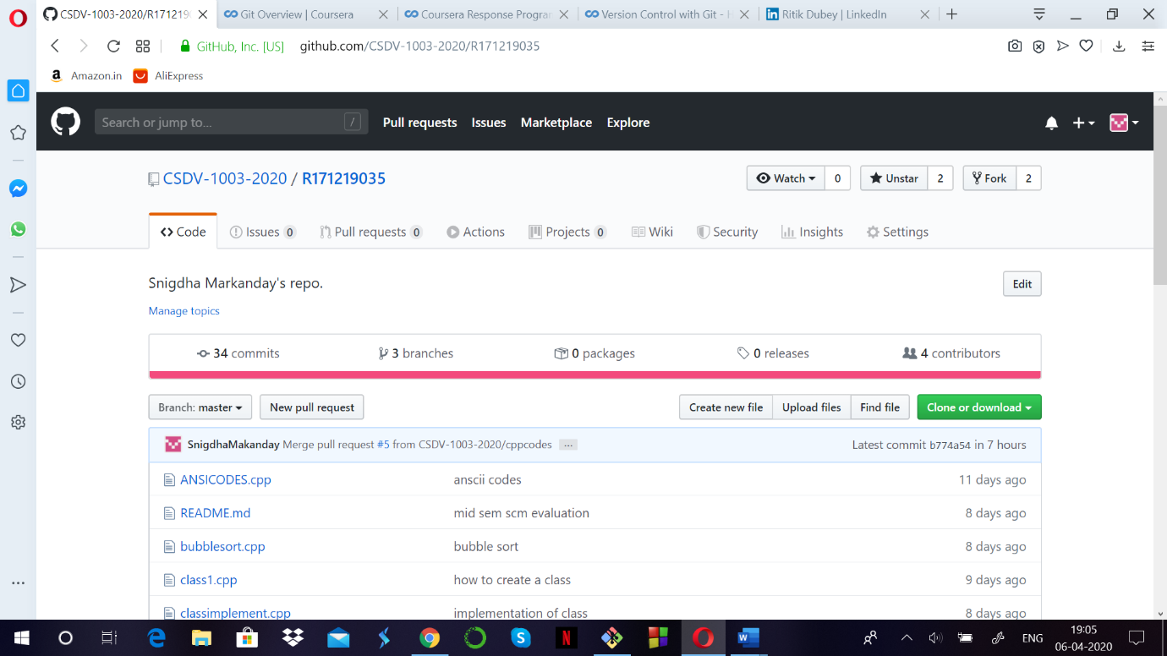

Step 2: Check for the changes the other user has made.

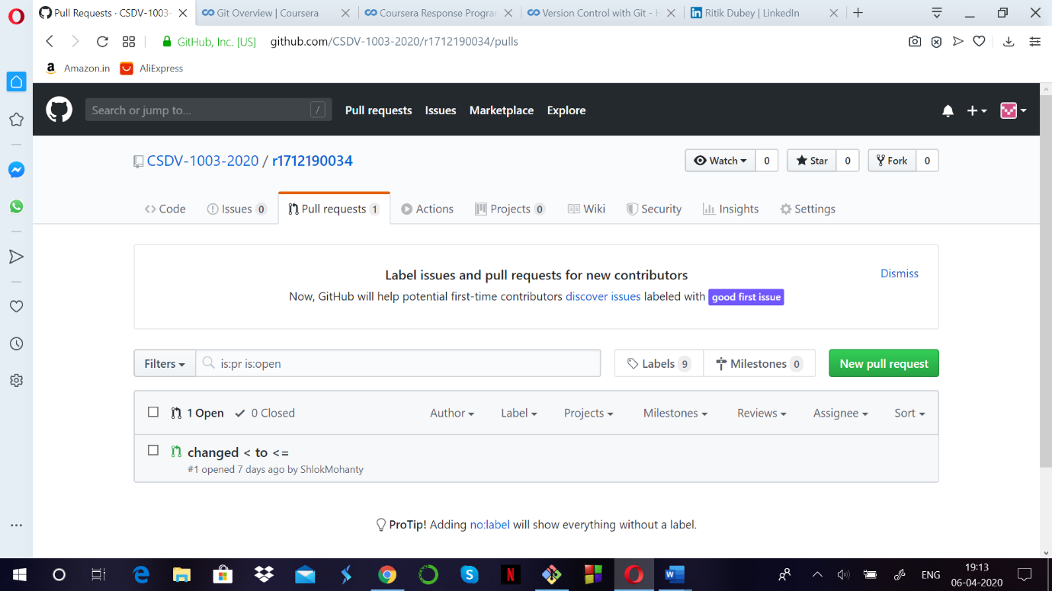

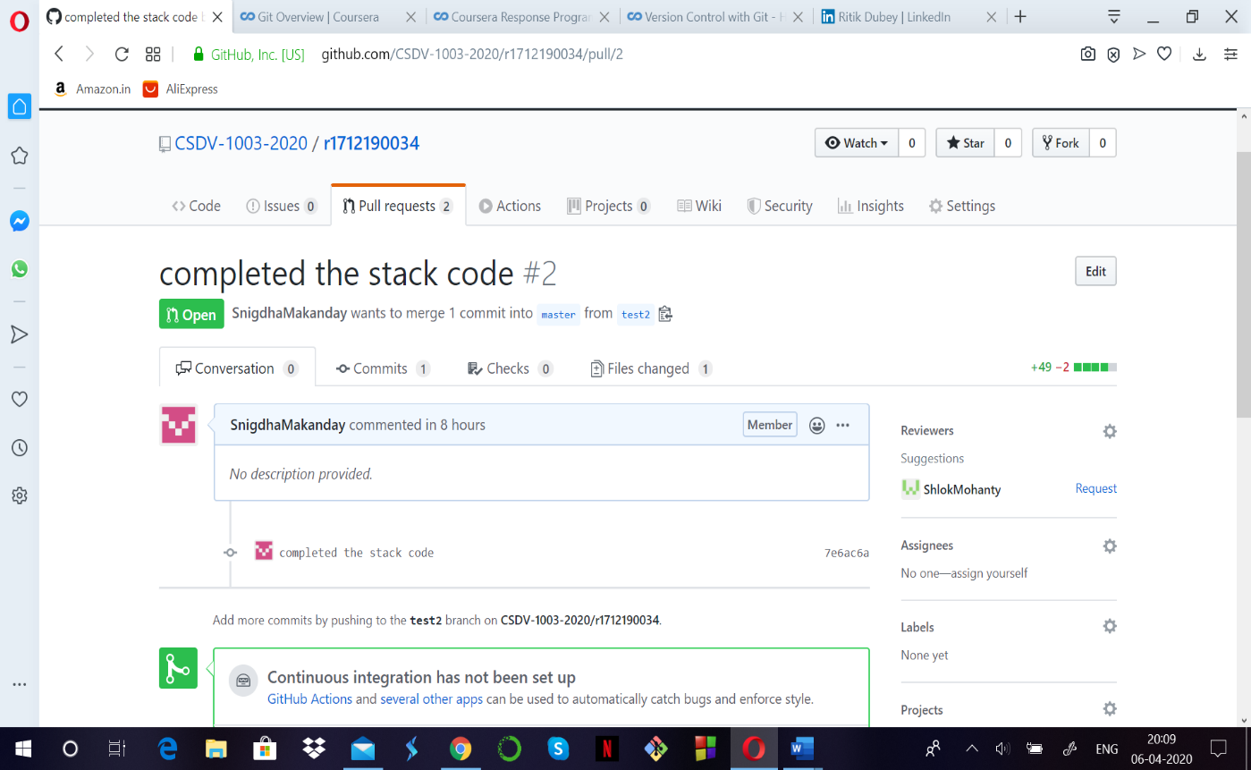

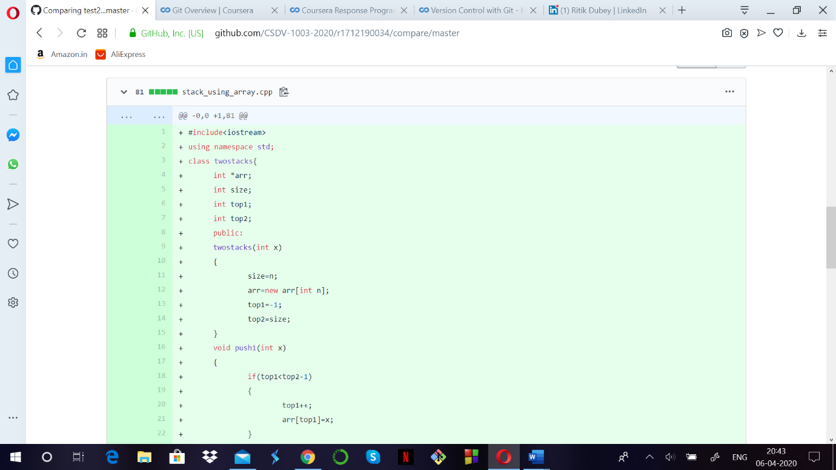

Step 3: The pull request can either be merged, or closed, after checking for the contents of the pull request.

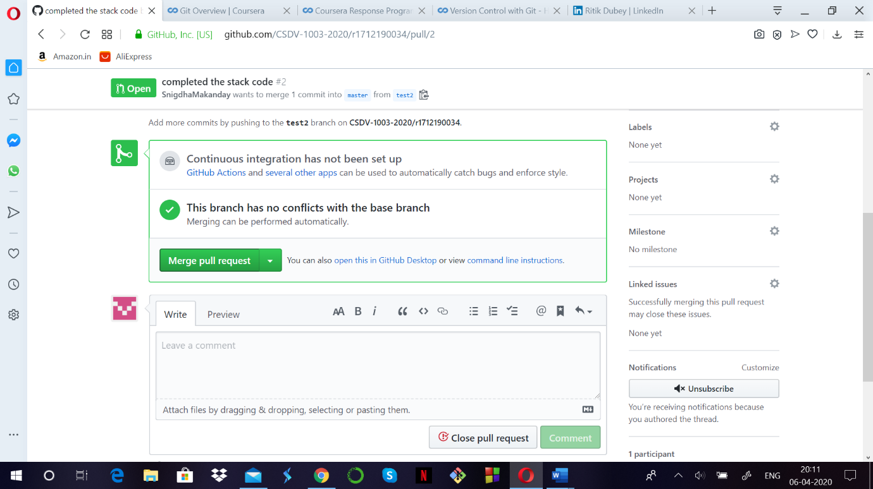

Step4: Confirm merging the pull request

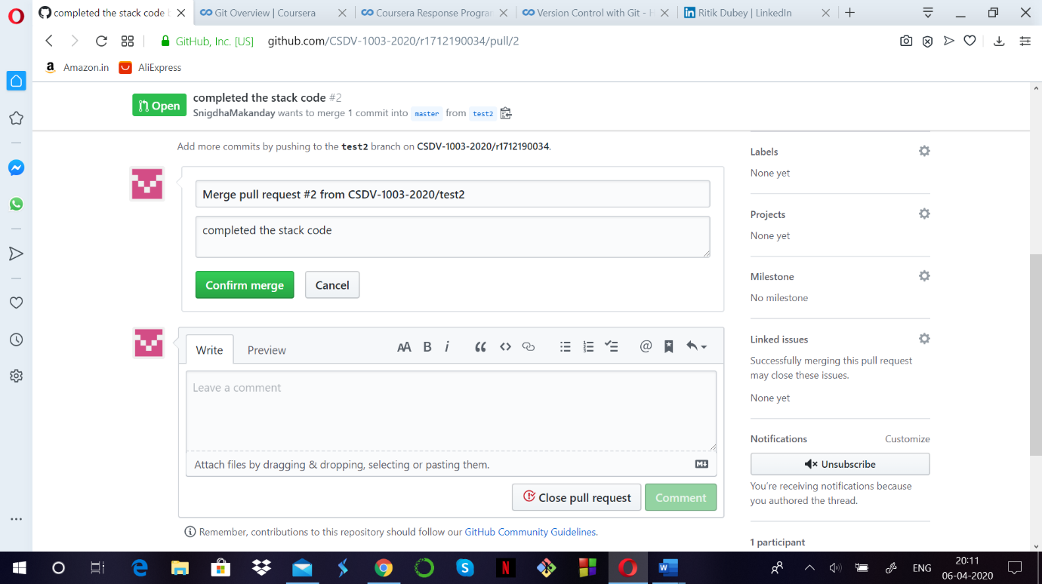

Step 5: The pull request is accepted and successfully merged.

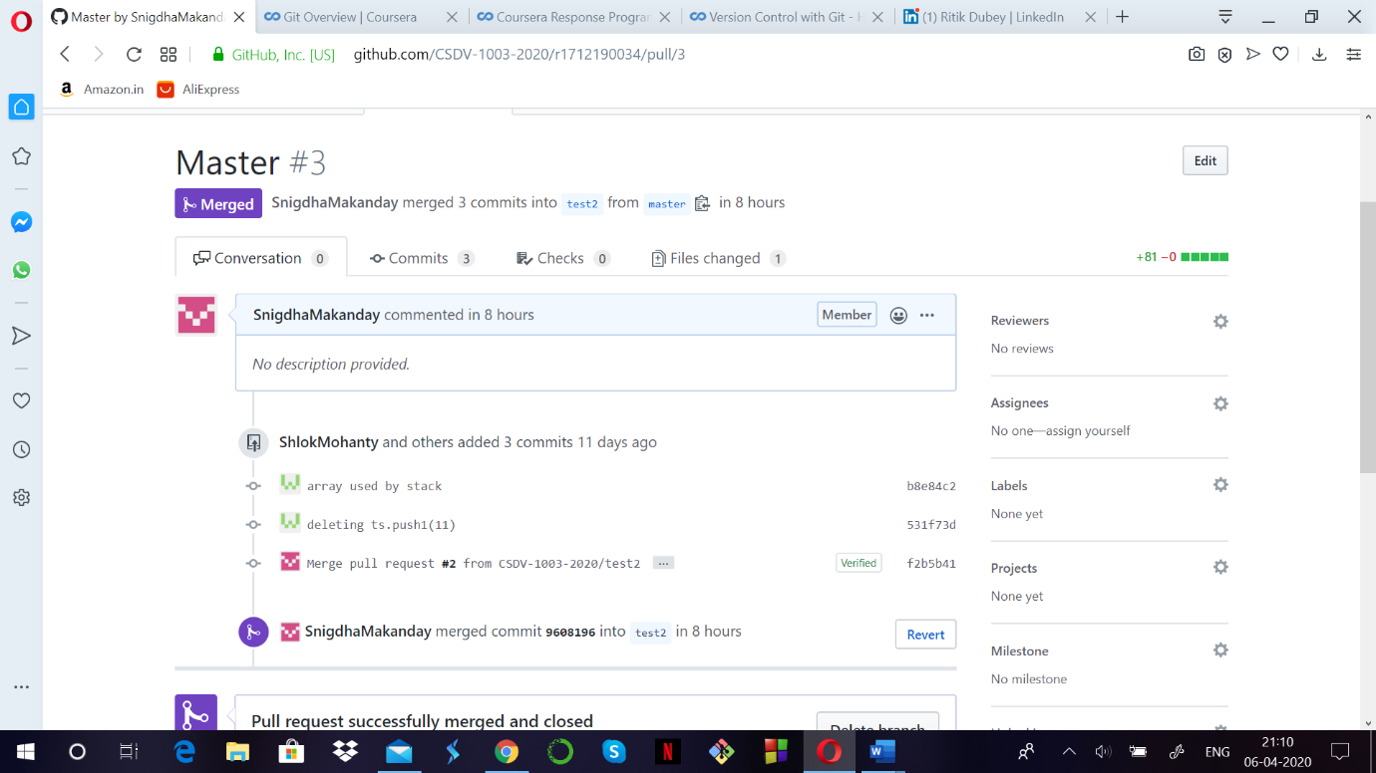

**Steps for creating a pull request:**

Step1: You can either clone the repository and edit the contents of the file using Git bash or can Fork the repository and edit the files on Github .

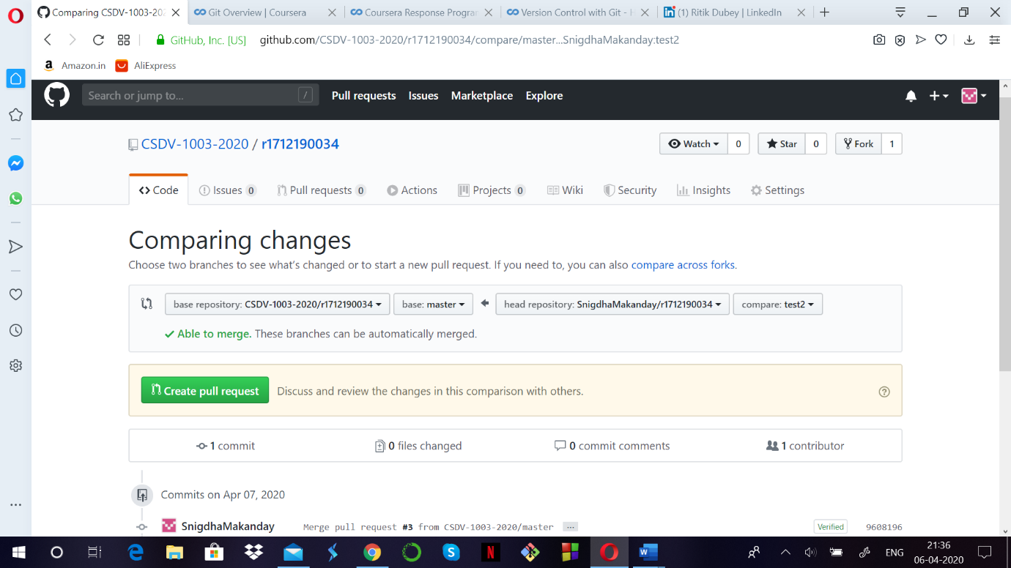

Step2: You can generate a pull request for the same.

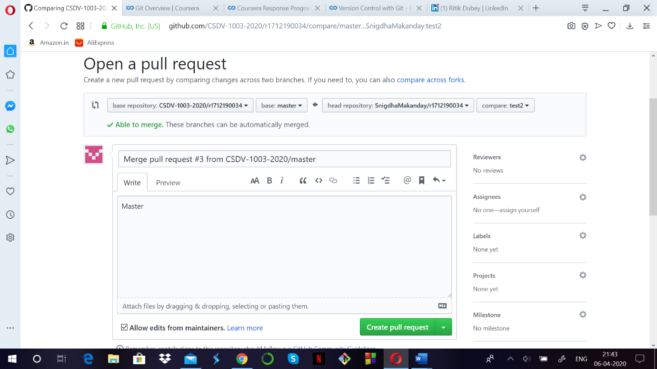

Step3: After creating the pull request, wait for the contributor to accept or reply it. In case your pull request gets accepted, the following message will be displayed.

